INSY6112
Assignment 1

Tasveer Bhoola
ST10439435

Question 1
I recommend a NoSQL database
NoSQL databases are mostly used in web applications and when using large amounts of data because some of its advantages are that it has high scalability and high availability. NoSQL databases are good at adapting to changing requirements, it can store data in easier and better understanding ways and uses fewer transformations when storing and retrieving data. (Oracle.com, 2020)

Scalability: By adding more commodity hardware, NoSQL databases can accommodate high data volumes and user traffic because they are made to grow horizontally. Without requiring major adjustments to the underlying infrastructure, this makes it simpler to manage the growing needs of contemporary applications. This will help with the companies need to accommodate millions of users. (GeeksforGeeks, 2020)
Flexibility: Because NoSQL databases don't implement a schema, they can manage both structured and semi-structured data. Documents, graphs, and key-value pairs are just a few of the many data kinds that may be stored and managed more easily thanks to this versatility. Using a no SQL database will allow the users to post different types of content Without any schema constraints. (GeeksforGeeks, 2020)
Performance: NoSQL databases can provide faster performance than traditional relational databases since they are designed to handle enormous volumes of data. This will improve the user experience as there is a lower latency, which will help to update the users feeds faster improving user engagement. (GeeksforGeeks, 2020)

- The database must hold data about the user’s profile, which includes a user’s personal details such as name, surname, username, passwords and any custom settings. (GeeksforGeeks, 2024)

- The database should store content shared by the user such as posts, photos and videos. (GeeksforGeeks, 2024)

- The database should store data of a user’s interactions with shared content such as likes, comments, dislikes, views, shares and favorites. (GeeksforGeeks, 2024)

- The database should also contain data such as a user’s followers, who a user is following and a user’s friendship status with another user. (GeeksforGeeks, 2024)

- The database should contain data of a user’s notifications and alerts so that a user gets instantly notified if another user interacts with their profile or one of their posts. (GeeksforGeeks, 2024)

- Document-based databases are nonrelational databases that store data in documents like JSON, BSON, or XML. They offer a flexible schema, allowing for faster creation and maintenance making it good at storing data like user profiles, comments and posts. Collections store documents with similar contents, and there are no foreign keys required. Open formats like XML and JSON are used to build documents, making them more accessible and efficient for applications. (GeeksforGeeks, 2022)

- A key-value store is a nonrelational database, storing data in key-value pairs. It's similar to a relational database with only two columns being the key and the value. Some of its key features is that it has fast data retrieval as is has direct key access, scalability is good as it is designed to scale horizontally and it has distributed storage, and it has fast speed which is good for notification data and caching frequently accessed content. (GeeksforGeeks, 2022)

- Column-oriented databases is a non-relational database that store data in columns, allowing for efficient data retrieval and efficient reading. This means that when analytics are run on a small number of columns, those columns can be read without the need to waste memory with the unneeded data. They are designed for large data storage and offer high scalability as it supports distributed data processing, storing the data in columns makes it more efficient to compress, and faster query performance, making them ideal for analytical queries. (GeeksforGeeks, 2022)

- Graph-based databases store data as nodes, with the connections between different nodes being called links or relationships, ideal for complex queries. They use fast graph traversal algorithms for quick retrieval of relationships. They are used when the relationship between the data is just as important as the data. Key features include relationship-centric storage, real-time query processing, and schema flexibility which makes it good for managing social connections, user interactions and followers. (GeeksforGeeks, 2022)

- Volume – The social media platform has millions of users, all of which have their own data causing there to be a high volume of data. All the data from a user’s profile, posts, comments, likes and shares causes there to be petabytes of data being stored and managed. (BIG DATA LDN, 2018)

- Velocity – The speed in which the data is coming in. Users will be continuously interacting with content causing there to be a high amount of incoming data which needs to be instantly processed and have real time updates. (BIG DATA LDN, 2018)

- Variety - data can be presented in many different formats like video’s, text’s, photo’s, etc. Each format of data has a different way of being stored, because of this need a NoSQL database is ideal as it is good at handling multiple data types efficiently. (BIG DATA LDN, 2018)
QUESTION 2
ENTITY RELATIONSHIP DIAGRAM
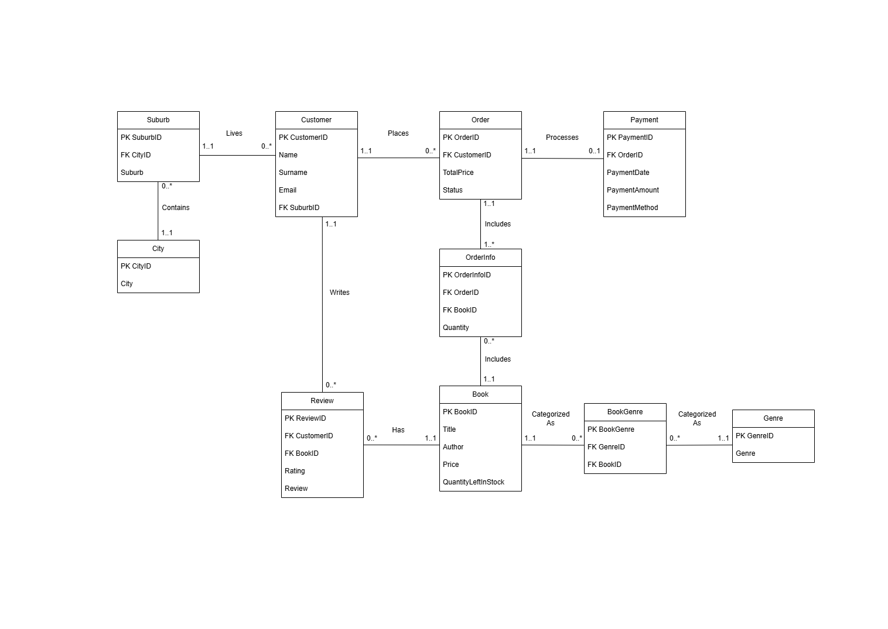

PK – Primary Key
FK – Foreign Key

Reference list
GeeksforGeeks, 2020. Top 5 Reasons to Choose NoSQL. [online] Available at: https://www.geeksforgeeks.org/top-5-reasons-to-choose-nosql/ [Accessed 23 March 2025].
GeeksforGeeks, 2024. How to Design Database for Social Media Platform. [online] Available at: https://www.geeksforgeeks.org/how-to-design-database-for-social-media-platform/ [Accessed 23 March 2025].
Oracle.com, 2020. Why Do Developers Prefer NoSQL Databases? [online] Available at: https://www.oracle.com/za/database/nosql/what-is-nosql/ [Accessed 23 March 2025].
GeeksforGeeks, 2022. Types of NoSQL Databases. [online] GeeksforGeeks. Available at: https://www.geeksforgeeks.org/types-of-nosql-databases/ [Accessed 24 March 2025].
BIG DATA LDN, 2018. Big Data: The 3 Vs explained. [online] www.bigdataldn.com. Available at: https://www.bigdataldn.com/en-gb/blog/data-engineering-platforms-architecture/big-data-the-3-vs-explained.html [Accessed 24 March 2025].

